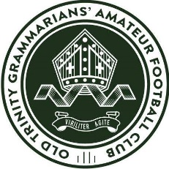

Old Trinity Football Club – COACHING POSITIONS

The OLD TRINITY Grammarians Amateur Football Club is seeking enthusiastic, committed and experienced individuals to apply for coaching roles in its Senior football department for season 2022.
Old Trinity Grammarians Amateur Football Club currently competes in the Premier ‘A’ division of the VAFA.
The club is also currently looking for applicants for the following coaching positions for the 2022 season:
  - Senior Men’s Head Coach
  - Senior Women’s Head Coach
  - Reserves Men’s Head Coach
  - Under 19’s Men’s Head Coach
- Assistant Coaches for all teams
All applicants must possess proven leadership skills having successfully led and developed players, assistant coaches and support staff. They must strive to build a club first culture, that is inclusive of every player. Coaches are expected to make a significant and positive collaborative contribution to the supportive and inclusive nature of our football club under the leadership of our Director of Coaching. They must be a contributing member of a team, who will work closely together to benefit the club, players, committee and members.
The successful candidates will need to demonstrate:
  - Level 1 coaching accreditation (Level 2 for Senior Men’s and Women’s Teams)
  - Demonstrate strong knowledge and experience in the game
  - A high level of organisational leadership
  - Ability to develop players across ages
  - Ability to work with the Director of Coaching and other coaches, including assistants within the club
  - Identify and recruit new players to the club
  - Excellent verbal and written communication skills and presentation skills.
  - Ability to use technology to advance coaching, communication and player education methods and game play style.
Playing and non-playing coaches will be considered for the role(s).
Remuneration: To be negotiated with the successful applicants

Expressions of interest, including contact details and previous experience should be referred by email to Director of Coaching Paul Griffiths at oldtrinityfc.coaching@gmail.com

